Due to the difference in PRC curve, the setup of thresholds based on the recall and precision is not very reasonable:

1. Here the r = 0.96, p = 0.9
2. Result:  
   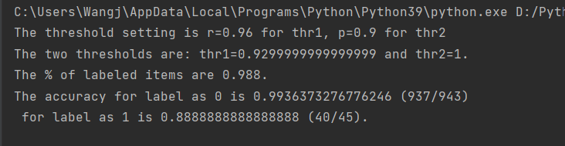
   1. Thresholds are 0.9299 and 1
   2. Incorrect label:  
      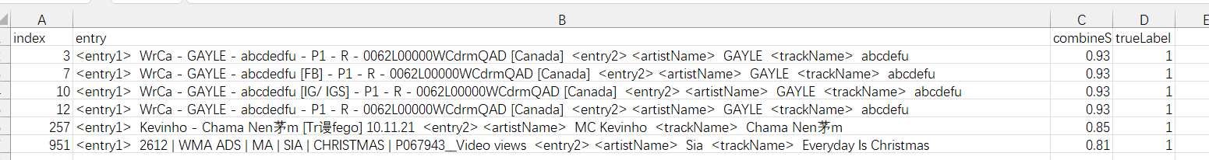
      1. The first several scores ~ 0.93 should be categorized as 1!
3. Proposal:
   1. Directly set the thresholds